EXP NO 1:
CREATE A SIMPLE CLOUD SOFTWARE APPLICATION AND PROVIDE IT AS A SERVICE USING ANY CLOUD SERVICE PROVIDER TODEMONSTRATE SOFTWARE AS A SERVICE (SAAS).

AIM: To create a simple cloud software application and provide it as a service using any cloud service provider to demonstrate software as a service (saas).
procedure:
step1: go to zoho.com
step 2: login to the zoho.com
step 3: select one application
step 4: enter application name
step 5: created new application
step 6: select one form
step 7: the software has been created.
Output
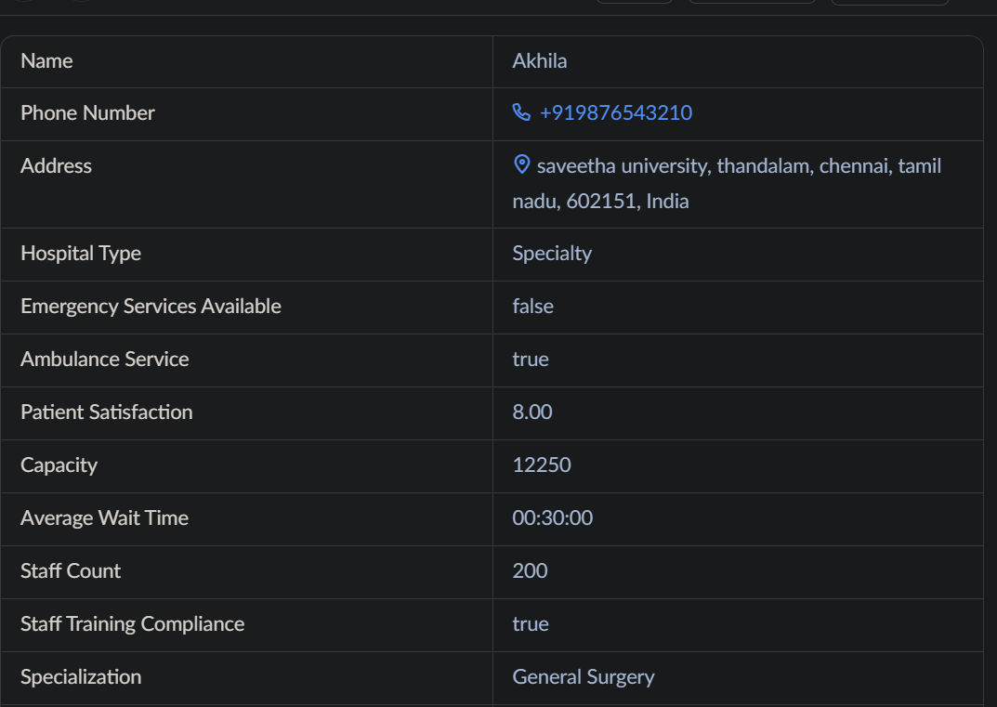

RESULT:
Successfully created a simple cloud software application and provide it as a service using any cloud service provider to demonstrate software as a service (SaaS).
EXP NO 2:
CREATE A SIMPLE CLOUD SOFTWARE APPLICATION FOR FLIGHT RESERVATION SYSTEM USING ANY CLOUD SERVICE PROVIDER TO DEMONSTRATE SAAS.

AIM: To create a simple cloud software application for flight reservation system using any cloud service provider to demonstrate SaaS.
procedure:
step1: go to zoho.com
step 2: login to the zoho.com
step 3: select one application
step 4: enter application name
step 5: created new application
step 6: select one form
step 7: the software has been created.
Output
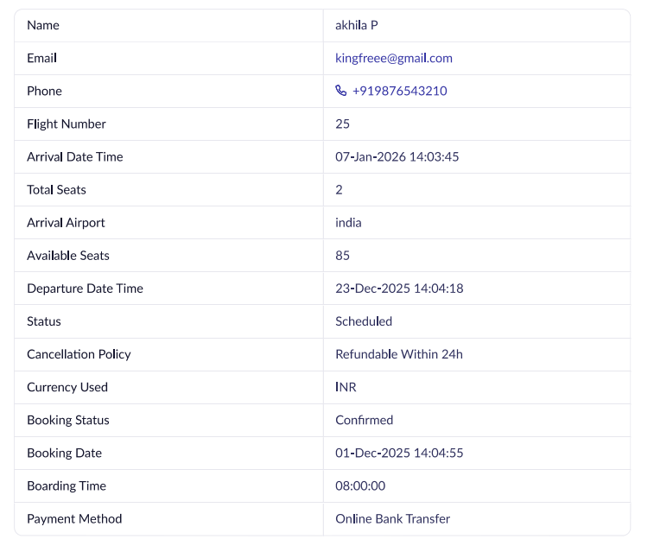

RESULT:
Successfully created a simple cloud software application and provide it as a service using any cloud service provider to demonstrate software as a service (SaaS).
EXP NO 3:
CREATE A SIMPLE CLOUD SOFTWARE APPLICATION FOR PROPERTY BUYING & RENTAL PROCESS (IN CHENNAI CITY) USING ANY CLOUD SERVICE PROVIDER TO DEMONSTRATE SAAS.

AIM: To Create a simple cloud software application for Property Buying & Rental process (In Chennai city) using any Cloud Service Provider to demonstrate SaaS.
procedure:
step1: go to zoho.com
step 2: login to the zoho.com
step 3: select one application
step 4: enter application name
step 5: created new application
step 6: select one form
step 7: the software has been created.
Output
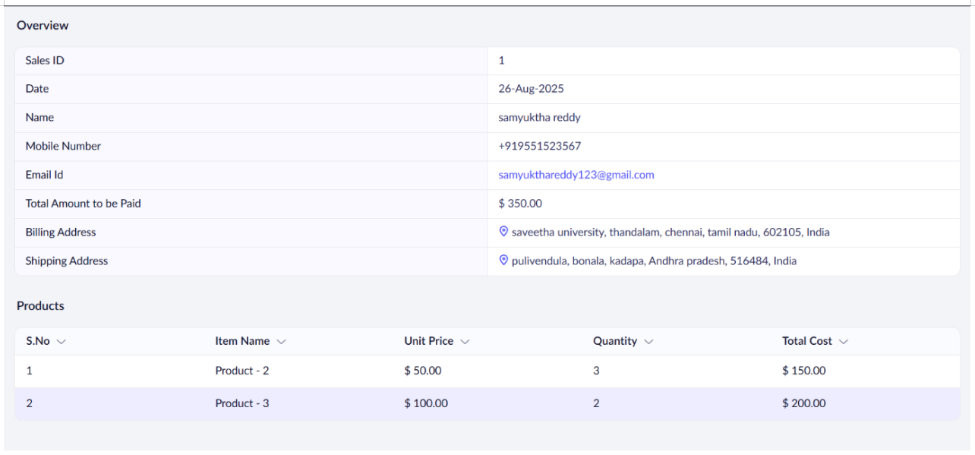

RESULT:
Successfully created a simple cloud software application and provide it as a service using any cloud service provider to demonstrate software as a service (SaaS).

EXP NO 4:
CREATE A SIMPLE CLOUD SOFTWARE APPLICATION FOR CAR BOOKING RESERVATION SYSTEM USING ANY CLOUD SERVICE PROVIDER TO DEMONSTRATE SAAS.

AIM: To Create a simple cloud software application for Car Booking Reservation System using any Cloud Service Provider to demonstrate SaaS.
procedure:
step1: go to zoho.com
step 2: login to the zoho.com
step 3: select one application
step 4: enter application name
step 5: created new application
step 6: select one form
step 7: the software has been created.
Output
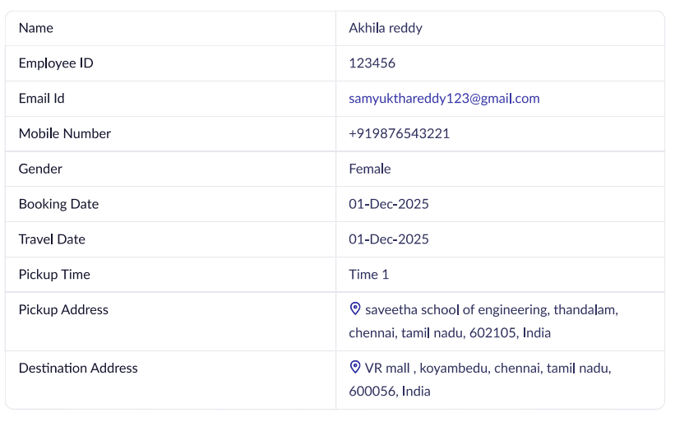

RESULT:
Successfully created a simple cloud software application for car booking reservation system using any cloud service provider to demonstrate SaaS

EXP NO 5:
CREATE A SIMPLE CLOUD SOFTWARE APPLICATION FOR LIBRARY BOOK RESERVATION SYSTEM FOR SIMATS LIBRARY USING ANY CLOUD SERVICE PROVIDER TO DEMONSTRATE SAAS

AIM: To Create a simple cloud software application for Library book reservation system for SIMATS library using any Cloud Service Provider to demonstrate SaaS
procedure:
step1: go to zoho.com
step 2: login to the zoho.com
step 3: select one application
step 4: enter application name
step 5: created new application
step 6: select one form
step 7: the software has been created.
Output
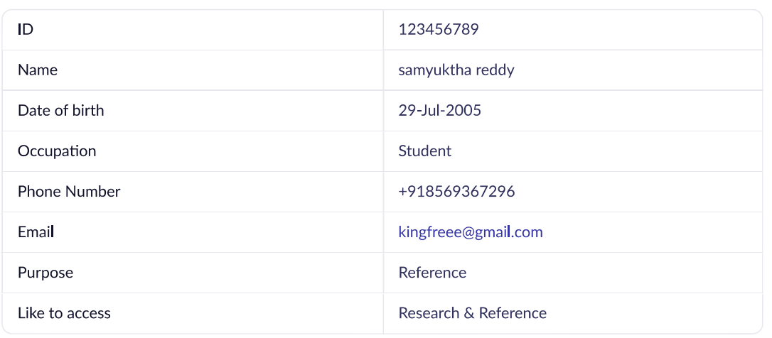

RESULT:
Successfully created a simple cloud software application for Library book reservation system using any cloud service provider to demonstrate SaaS

